Blackgarlic.ir/wp-admin

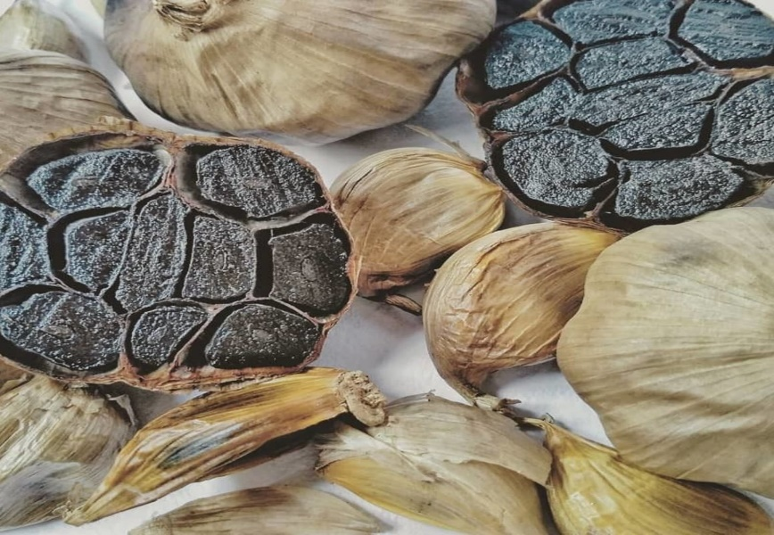

طلای سیاه
اولین تولید کننده سیر سیاه در ایران

